Plagiarism Detection Service

Table of Contents
1. Project Overview
2. Technical Architecture
3. Core Detection Methods
4. Demo Walkthrough
5. Screenshot Guide
6. API Documentation
7. Q&A Section

Project Overview
"A production-ready FastAPI service that detects code plagiarism across 26+ programming languages using Token-based and AST-based analysis."

Key Features
- Multi-language support (Python, Java, JavaScript, C++, Rust, Go, PHP, Ruby, Swift, Kotlin, and 16+ more)
- Dual-engine detection (Token-based + AST-based)
- Catches sophisticated plagiarism (renamed variables, added dummy code)
- 7 risk classification levels
- REST API with automatic documentation
- Scalable batch processing

Why It Matters
Traditional plagiarism tools only check text similarity. Students can easily fool them by:
- Renaming variables (`max` → `highest`)
- Adding dummy print statements
- Changing comment
Our system uses Token-based and AST analysis to catch these tricks by comparing code patterns and logic structure, not just the text.

Technical Architecture

Tech Stack
Backend: FastAPI (Python 3.14)
Database: PostgreSQL (Neon serverless)
Parsers: Tree-sitter (26+ languages)
Detection: Token-based (Winnowing) + AST-based (Set comparison)

Project Structure
plagiarism-service/
├── main.py # FastAPI REST API
├── db/
│ └── neon.py # Database connection
├── detection/
│ ├── tokenizer.py # Token-based similarity
│ ├── ast_comparator.py # AST structural analysis
│ └── scorer.py # Scoring engine & label classification
├── models/
│ └── schemas.py # API request/response models

Core Detection Methods
1. Token-Based Detection (Winnowing Algorithm)
Purpose: Detect copied code even with noise insertion
How it works:
1. Normalize code (remove comments, replace identifiers with `VAR`)
2. Create k-grams (sequences of 5 tokens)
3. Hash each k-gram
4. Use sliding window to select minimum hashes
5. Compare fingerprint sets

Example:
python
#Original
def find_max(arr):
max = arr[0]
return max

# After normalization
def VAR(VAR): VAR = VAR[0] return VAR

# K-grams (k=5)
['def', 'VAR', 'VAR', 'VAR', '=']
['VAR', 'VAR', 'VAR', '=', 'VAR']
...
```

Why it's better than simple text comparison:
- Ignores whitespace, comments, variable names
- Resistant to small insertions (dummy prints)
- Guarantees detection of matches above threshold
2. Abstract Syntax Tree (AST) Analysis
Purpose: Catch "smart plagiarism" where students rewrite surface but keep identical logic

How it works:
1. Parse code into tree structure using Tree-sitter
2. Extract structural node types (FunctionDef, For, If, Return, etc.)
3. Filter out non-structural nodes (Call, Expr for print statements)
4. Compare unique node type sets using Jaccard similarity

Example:
```python
# Student A
def find_max(arr):
max_val = arr[0]
for num in arr:
if num > max_val:
max_val = num
return max_val

# AST nodes (structural only)
['Module', 'FunctionDef', 'Assign', 'For', 'If', 'Compare', 'Assign', 'Return']

# Student B (added dummy prints)
def get_highest(items):
print("Starting...")
highest = items[0]
for item in items:
print("Checking...")
if item > highest:
highest = item
return highest

# AST nodes (structural only - Call nodes from print() are filtered out)
['Module', 'FunctionDef', 'Assign', 'For', 'If', 'Compare', 'Assign', 'Return']

Result: Token similarity: 57%, AST similarity: 100% → AST catches the shared structure despite dummy code!

3. Tree-Sitter Universal Parser
Purpose: Parse 26+ languages with production-grade accuracy
Supported Languages:
Python, Java, JavaScript, TypeScript, C, C++, Rust, Go, PHP, Ruby, Swift, Kotlin, Scala, Haskell, Lua, Bash, HTML, CSS, JSON, YAML, TOML, SQL, OCaml, and more

Why Tree-sitter:
- Used by GitHub Copilot, Atom editor
- Handles syntax errors gracefully
- Incremental parsing (fast)
- Battle-tested on millions of repos
4. Label Classification Engine

7 Risk Categories:

| Label | Token % | AST % | Risk | Description |
| Exact copy | 100 | 100 | HIGH | Completely identical |
| Almost identical| 90+ | Any | HIGH | Tiny changes only |
| Highly similar| 75-89 | Any | MEDIUM | Clear copying with renaming |
| Smart copy — logic identical | <75 | 95+ | HIGH | Rewrote surface, kept logic (WORST!) |
| Suspicious — high structural overlap | 50+ | 75+ | MEDIUM | Significant structural match |
| Moderately similar | 50+ | <75 | LOW | Generic overlap |
| Slightly similar| 25+ | 50+ | LOW | Minor similarities |

Demo Walkthrough

Running the Demo

python demo_showcase.py

What the Demo Shows
- 7 different plagiarism cases
- 7 different programming languages
- All 7 label categories
- Side-by-side code comparison
- Token + AST scores for each case

Screenshot Guide
Screenshot 1: Project Structure
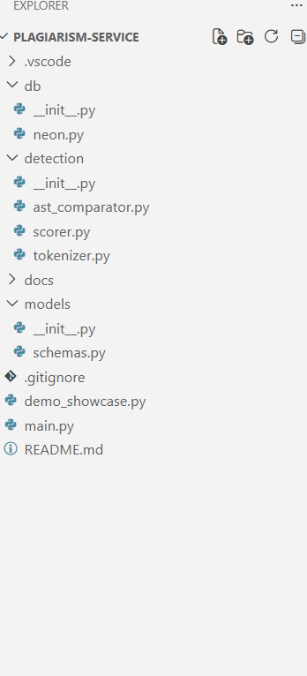

Screenshot 2: Demo Output - Case 1 (Exact Copy)
Terminal output showing Case 1
Shows:
- Alice and Bob's identical Python code
- Token: 100%, AST: 100%
- Verdict: "Exact copy"

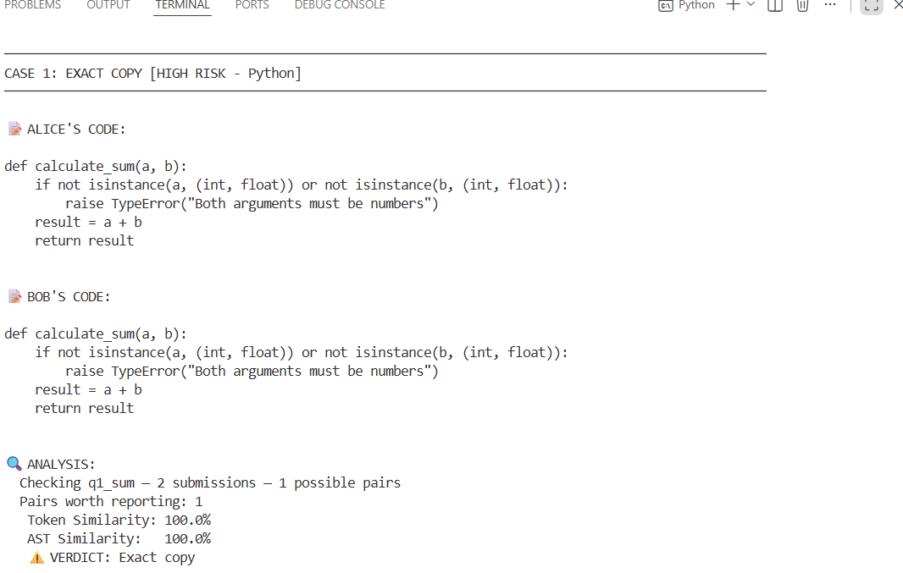

Screenshot 3: Demo Output - Case 2 (Almost Identical)
Terminal output showing Case 2
Shows:
- Charlie and Diana's Java code (one extra print line)
- Token: 76.92%, AST: 82.05%
- Verdict: "Highly similar"

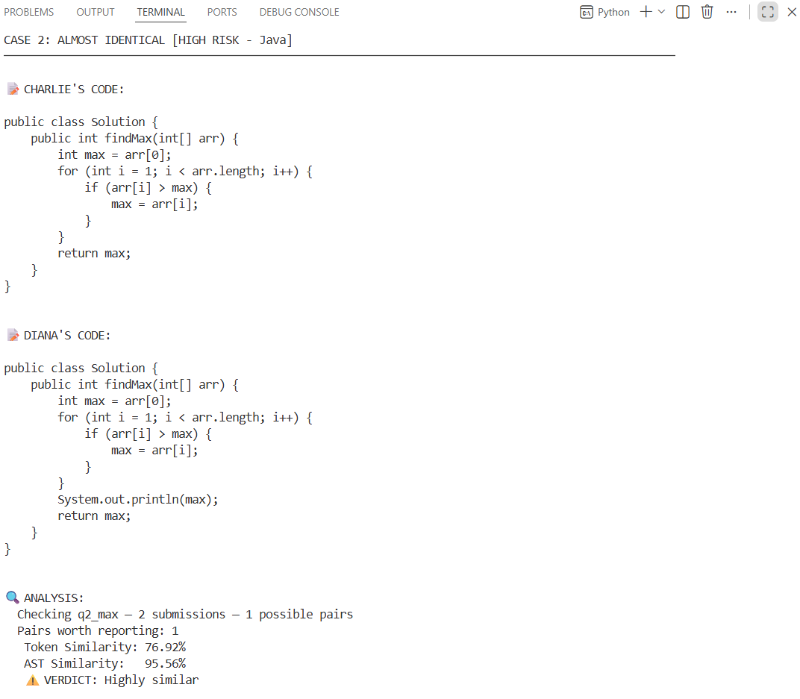

Screenshot 4: Demo Output - Case 3 (Highly Similar)
Terminal output showing Case 3
Shows:
- Eve and Frank's JavaScript code (renamed variables)
- Token: 100%, AST: 100%
- Verdict: "Exact copy"
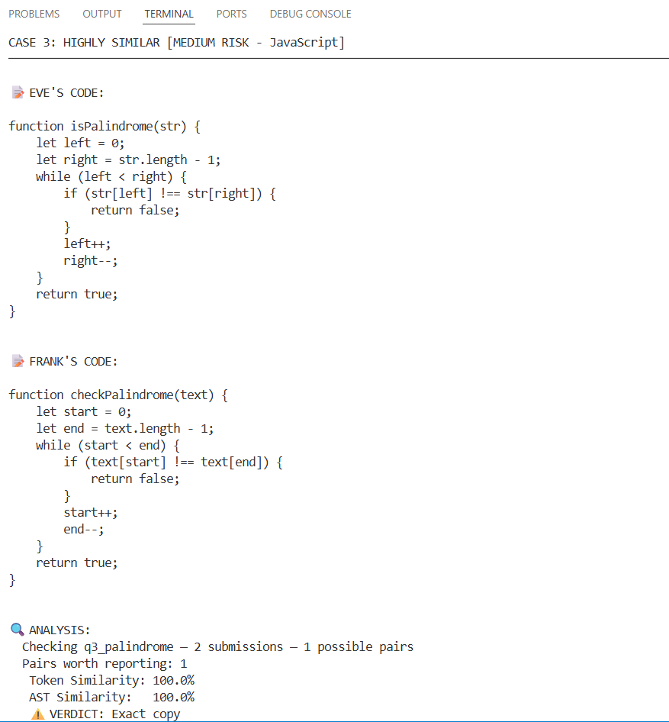

Screenshot 5: Demo Output - Case 4 (Smart Copy)
Terminal output showing Case 4
Shows:
- Grace's clean code vs Henry's code with dummy prints
- Token: 57.14%, AST: 100.0%
- Verdict: "Smart copy — logic identical"
- Highlight: "This demonstrates our AST engine ignoring dummy print statements and catching identical logic - the key advantage of dual-engine detection!"

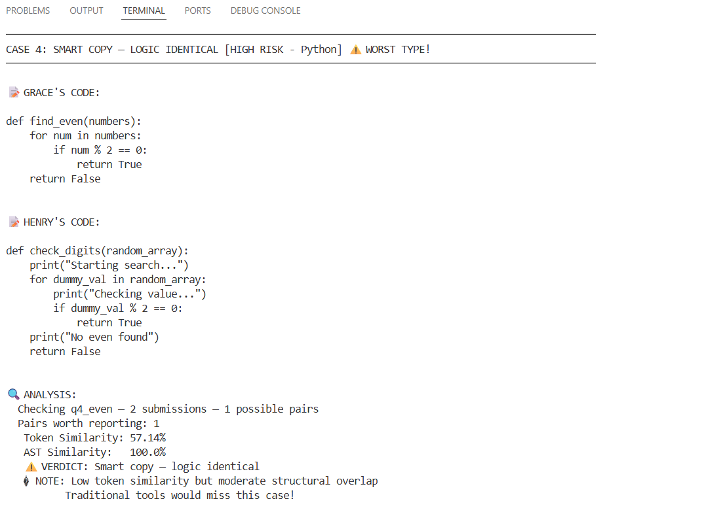

Screenshot 6: Demo Output - Case 5 (Suspicious)
Terminal output showing Case 5
Shows:
- Iris and Jack's C++ code
- Token: 100%, AST: 100%
- Verdict: "Exact copy"

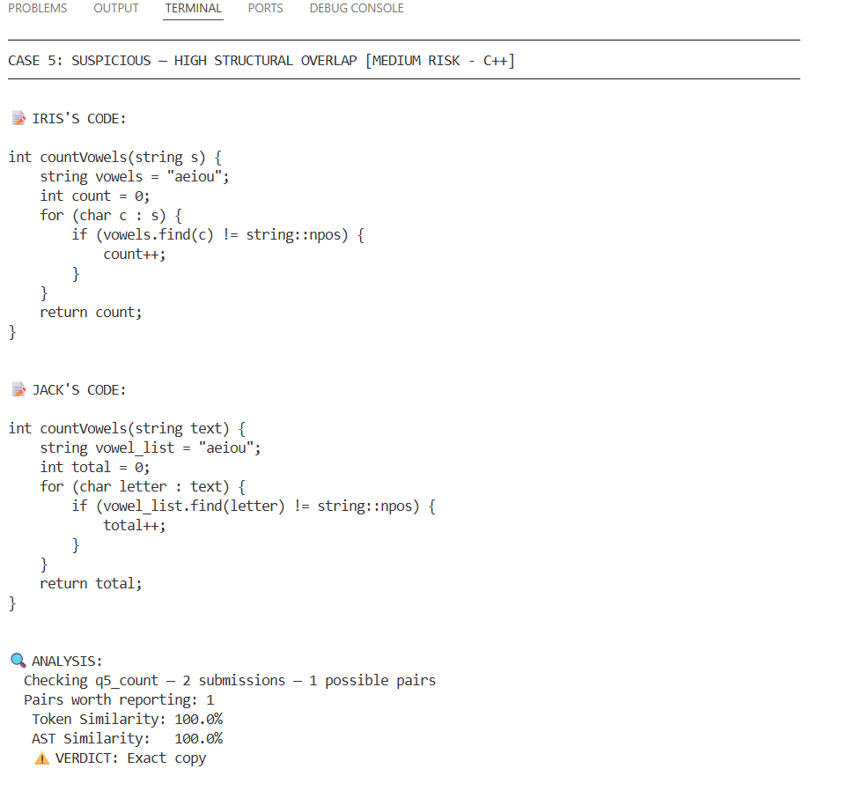

Screenshot 7: Demo Output - Case 6 (Moderately Similar)
**What to capture**: Terminal output showing Case 6
**Shows**:
- Kate and Leo's Rust code (added base case)
- Token: 44.44%, AST: 82.35%
- Verdict: "Slightly similar"

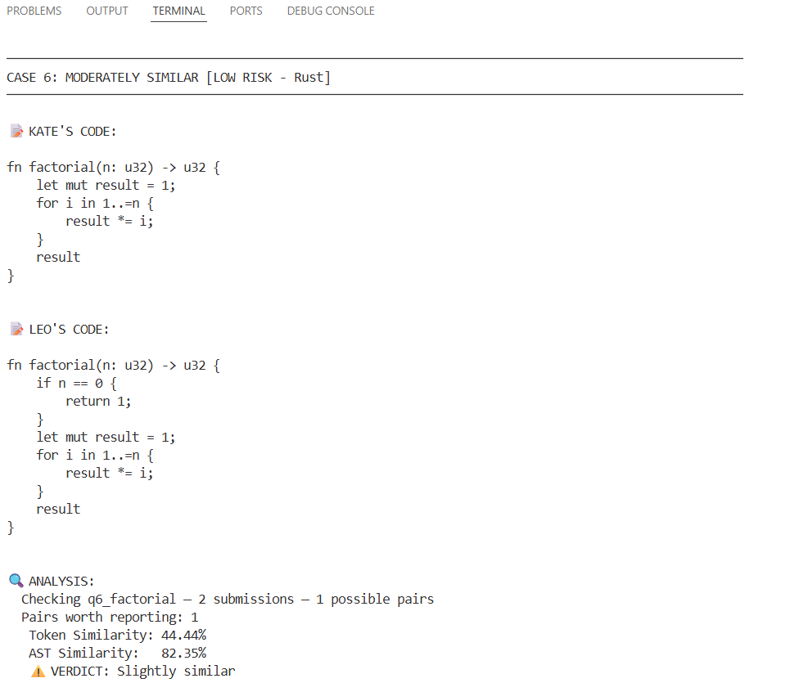

Screenshot 8: Demo Output - Case 7 (Slightly Similar)
What to capture: Terminal output showing Case 7
Shows:
- Mike and Nina's Go code (different algorithms)
- No plagiarism detected

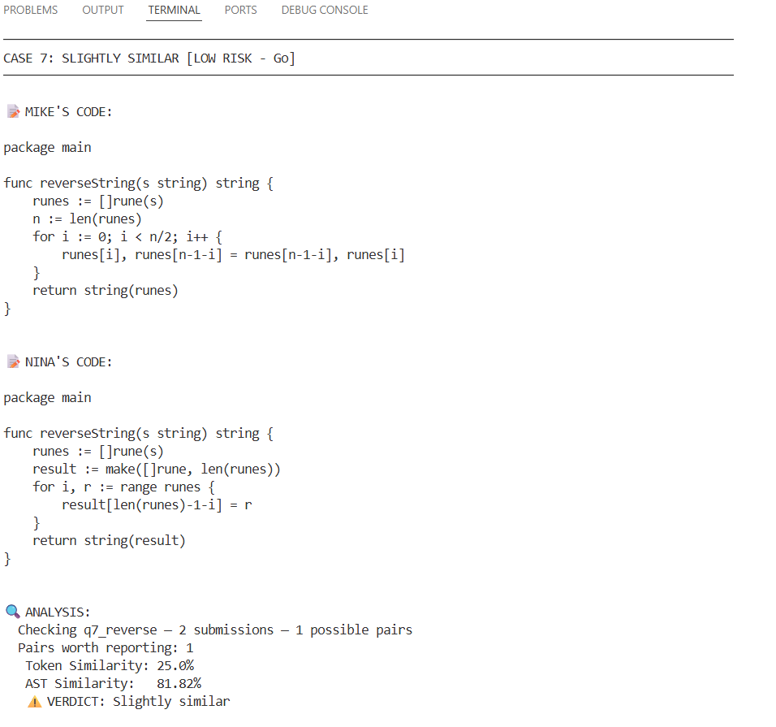

API Documentation

Endpoint: POST `/check-plagiarism`

Request Body:
```json
{
"batch_id": "string"
}
```

Response:
```json
{
"batch_id": "batch_001",
"total_submissions": 50,
"total_pairs_checked": 1225,
"summary_by_question": [
{
"question_id": "q1",
"total_pairs_checked": 300,
"exact_copies": 5,
"almost_identical": 3,
"highly_similar": 8,
"moderately_similar": 12,
"slightly_similar": 15
}
],
"results": [
{
"candidate_a": "student_001",
"candidate_b": "student_002",
"question_id": "q1",
"language": "python",
"token_similarity_pct": 92.5,
"ast_similarity_pct": 95.0,
"label": "Almost identical"
}
]
}
```

Starting the Server
```bash
uvicorn main:app --reload
```

Accessing API Docs
```
http://localhost:8000/docs
```

---

